Pizza Sales SQL Queries

A – KPI’s
1 – Total Revenue:
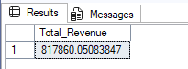

2 – Average Order Value:
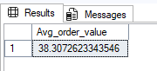

3 – Total Pizza Sold:
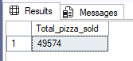

4 – Total Orders:
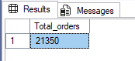

5 – Average Pizza Per Order:
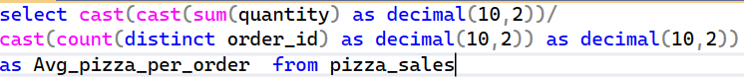
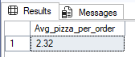

B – Charts SQL
1 – Daily Trend for Total Orders:
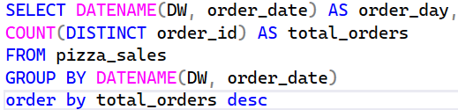
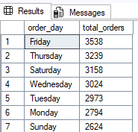
2 – Monthly Trend for Total Orders:
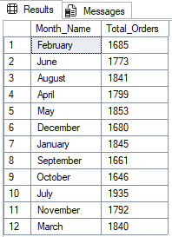
3 – Percentage of sales by pizza category:
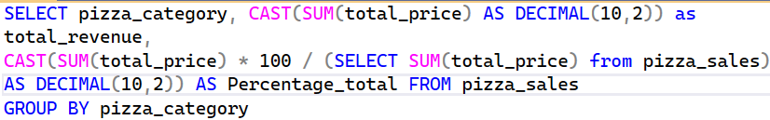
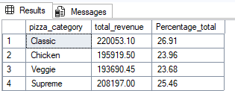
4 – Percentage of sales by pizza size:
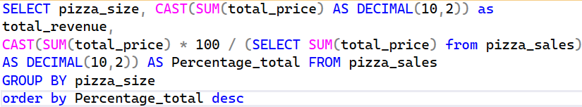
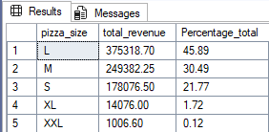
5 – Total pizza sold by pizza category:
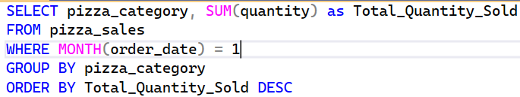
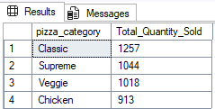

6 – Top 5 best sellers by Revenue, Total Quantity, Total Orders:
By Revenue ------
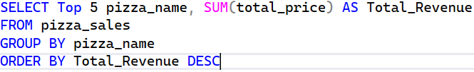
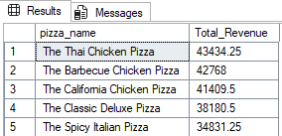
By Quantity ------
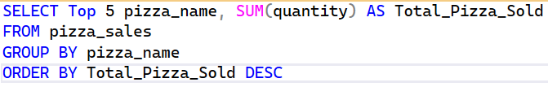
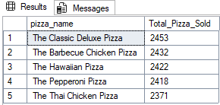
By Orders -----
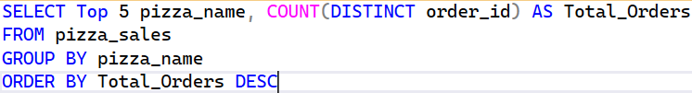
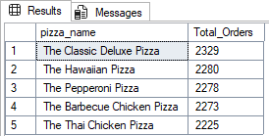

7 – Bottom 5 best sellers by Revenue, Total Quantity, Total Orders:
By Revenue ------
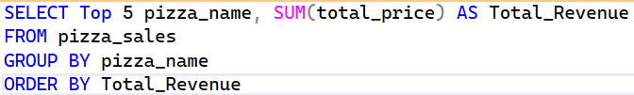
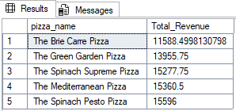
By Quantity ------
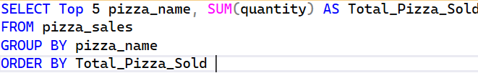
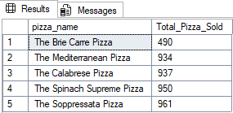
By Orders -----
